**Summer CEO Report**

**Analysis for CEO Age Estimation Error in Years, W/ Glasses v W/O (Chart 1)**

|  |  |  |
| --- | --- | --- |
|  | **W/ Glasses** | **W/O Glasses** |
| **Sample Size** | 48 (688) | 51 (1446) |
| **Average Error** | -4.61 | -5.19 |
| **Standard Error** | 2.92 | 3.70 |
| **R-Squared** | 0.86 | 0.78 |

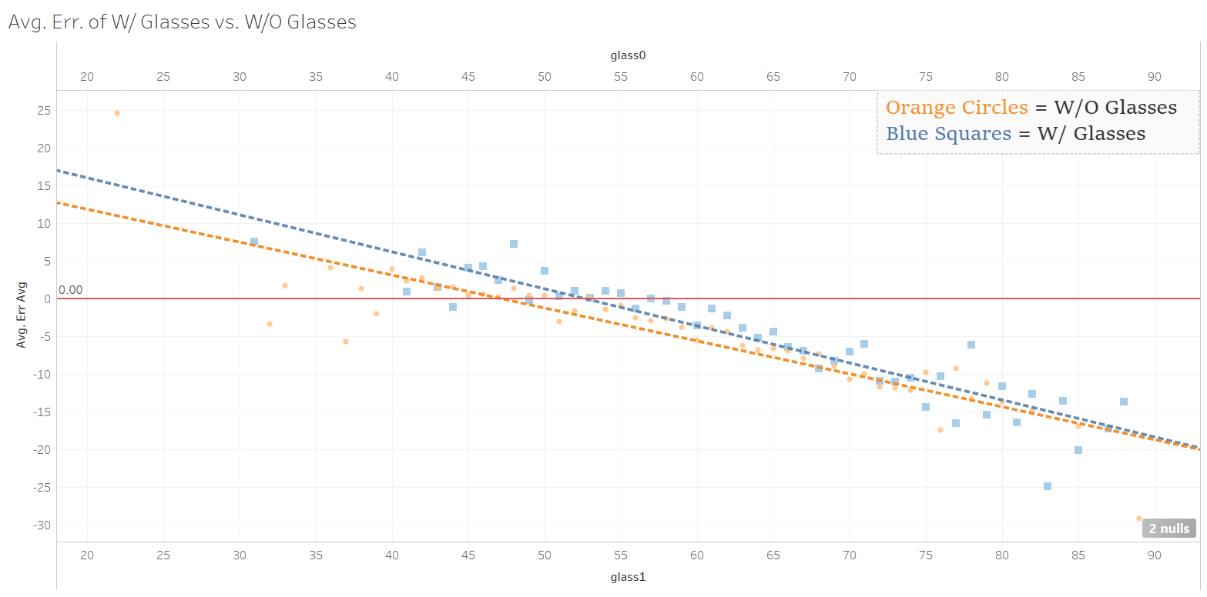

**Analysis for CEO Age Estimation Error in Years, W/ Logo v W/O (Chart 2)**

|  |  |  |
| --- | --- | --- |
|  | **W/ Logo** | **W/O Logo** |
| **Sample Size** | 39 (285) | 57 (1794) |
| **Average Error** | -3.31 | -5.16 |
| **Standard Error** | 3.25 | 3.81 |
| **R-Squared** | 0.65 | 0.80 |

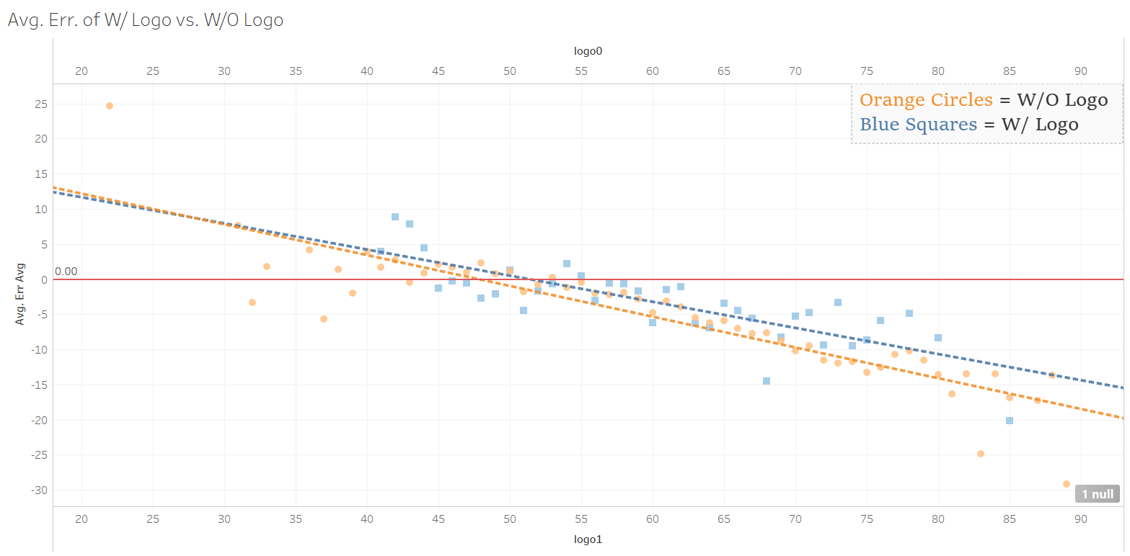

**Analysis for CEO Age Estimation Error in Years, Head-On v Side of Face (Chart 3)**

|  |  |  |
| --- | --- | --- |
|  | **Head-On** | **Side of Face** |
| **Sample Size** | 56 (1723) | 38 (358) |
| **Average Error** | -4.99 | -4.63 |
| **Standard Error** | 3.53 | 3.17 |
| **R-Squared** | 0.80 | 0.78 |

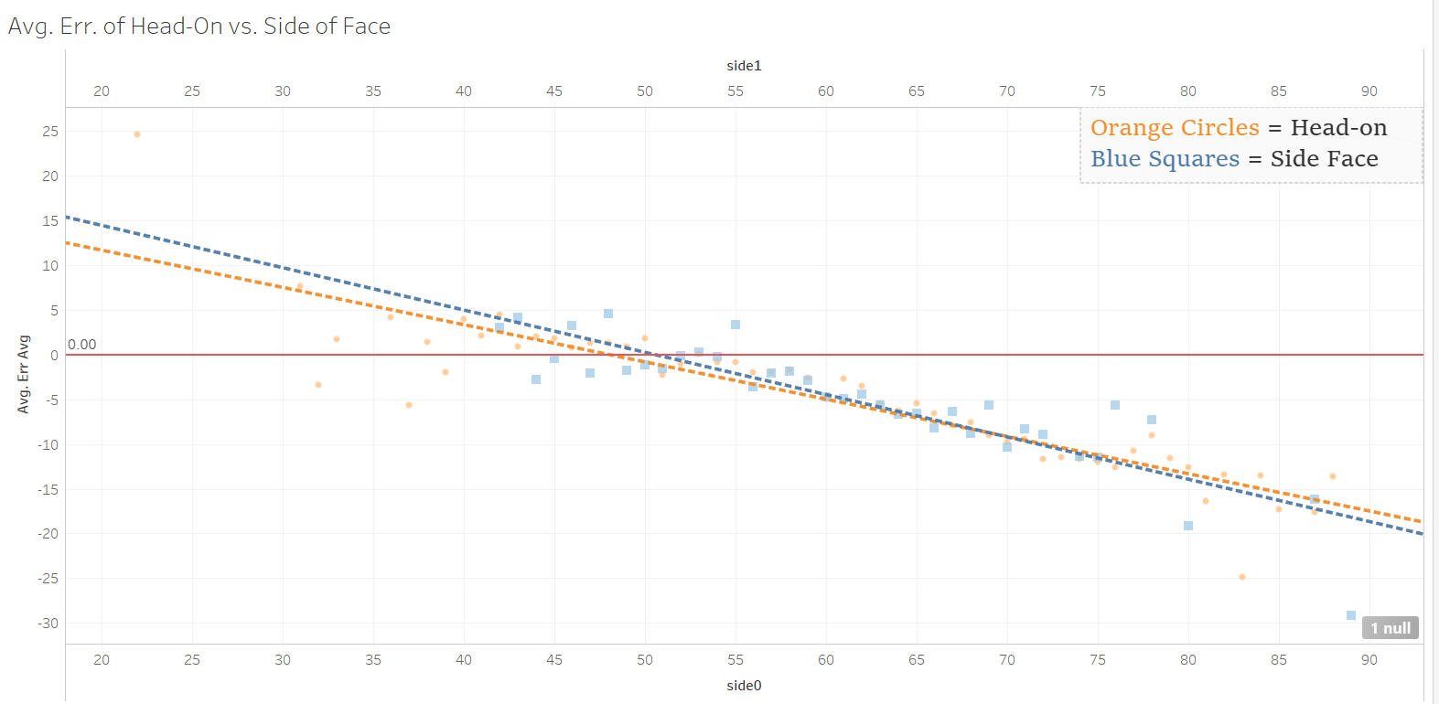

**Analysis for CEO Age Estimation Error in Years, Artificial v Natural Lighting (Chart 4)**

|  |  |  |
| --- | --- | --- |
|  | **Artificial** | **Natural** |
| **Sample Size** | 57 (1935) | 32 (76) |
| **Average Error** | -5.07 | -4.32 |
| **Standard Error** | 4.04 | 4.62 |
| **R-Squared** | 0.78 | 0.62 |

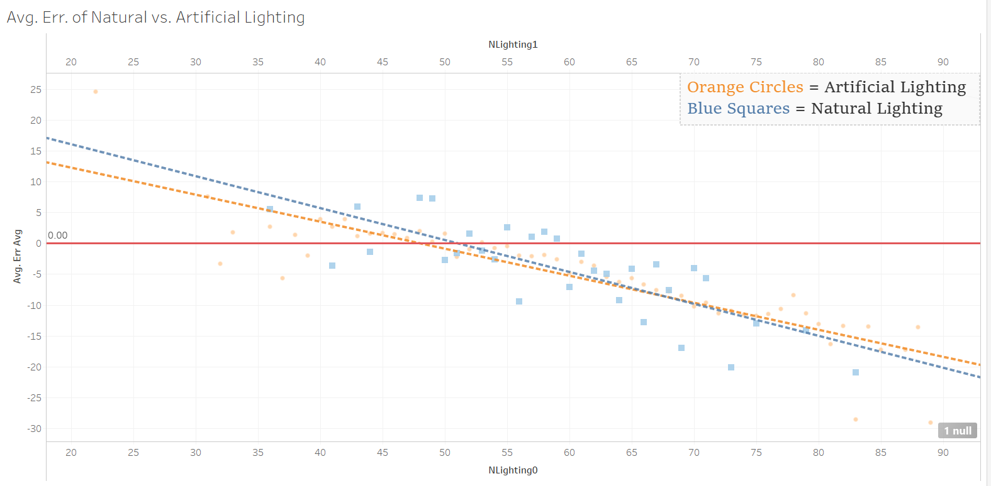

**Analysis:**

* For the glasses chart, there is a difference of ~2.5 years in the early forties, our first sample group to have a substantial sample size, with W/ Glasses having the greater error.
* The trend line for W/O Glasses intersects the zero-error line at 48, and the trend line for W/ Glasses intersects at 53, indicating that subjects who wear glasses appear as older than they actually are for roughly five years longer than those who don’t wear glasses.
  + This indicates that after passing the zero-error line, subjects who wear glasses consistently appear ‘less young’ than those are not wearing glasses. We say ‘less young’ here as, after passing the zero-error line, subjects are much more likely to have a negative error than a positive error, meaning that they appear younger than they actually are as opposed to older. However, the severity of the error will be smaller than that of subjects not wearing glasses, and hence, will appear less young relatively.
* The difference between the trend lines consistently diminishes after both pass the zero-error line, such that they eventually intersect at approximately age one hundred, an age eleven years older than our oldest sample size. As such, the difference in the trend lines in the early sixties is ~1.75, and less than a year by the late seventies.
* This data has matched our hypothesis that wearing glasses does cause a subject to appear as older than they actually are relative to subjects who aren’t wearing glasses. However, we did not consider the possibility that the margin in age estimation error would taper off as the subjects became older, such that the ‘effect’ of wearing glasses would eventually become negligible.
  + We believe that the reason for this is that glasses act similarly to feature-accentuating shadows cast by poor lighting, and are thus picked up by the facial recognition software as pronounced facial features prominent in those older than the subject.
* For the logo chart, the trend lines intersect at roughly age 28 and then begin converging, with the trend line for W/ Logo being set above the trend line for W/O Logo from then on out.
* Around the early forties, our first age group with a substantial sample size, the difference in error between the two trend lines, both errors still being positive, is ~0.75 years.
* The trend line for W/O Logo intersects the zero-error line at age 48, and the trend line for W/ Logo intersects at 51, indicating that the inclusion of logos in photos causes subjects to appear older than they actually are for roughly three years longer than subjects in photos without logos.
  + This indicates that after passing the zero-error line, photos that include the logo are consistently estimated to have the subject appear ‘less young’ than those whose photos do not have a logo included.
* As the subjects become older, we can see that the trend lines consistently diverge notably more after passing the zero-error line than before.
  + This indicates that photos including a logo appear closer to their actual age, and thus older, than those that do not include a logo. As time passes, this difference in apparent age becomes greater.
* This data matches with our previous hypothesis that logos being included in a photo would cause a subjects to appear older than they actually are for longer as opposed to those without a logo included. However, we did not consider the idea that this would follow after both trend lines passed the zero-error line, causing photos with logo to appear as ‘less young’ than those without logos.
  + We believe that the reason for this is that in the eyes of the facial recognition software, logos are interpreted as accentuated facial features similar to shadows cast across the face, causing the subject to thus be estimated as older than they actually are relative to photos of the same age that do not include logos.
* For the side face chart, in the early forties, the trend lines have a difference of ~1.5 years, with the trend line for Side Face having a more severe positive error.
* The Head-On trendline intersects the zero-error line at 48, and the Side Face trendline intersects at 50, indicating that photos in which the subject is turned rather than facing the camera head-on are estimated to appear as older than they actually are for a longer period of time, being roughly two years, as opposed to photos in which the subject is facing the camera head-on.
  + After passing the zero-error line, the Head-On trendline has a more severe average error that is consistently tapering, causing the Side Face trendline to appear as ‘less young’ up until the trendlines intersect.
* At the point in which the Side Face trendline intersects the zero-error line, the difference between the trendlines is ~0.9 years, with the Side Face trendline still being placed above the Head-On trendline.
* The trendlines intersect at age 69, indicating that after this age, photos in which the subject is facing the camera head-on are consistently estimated to be ‘less young’ as photos in which the subject is turned will have a more severe negative error. As the age becomes greater past this intersection, the difference between the trend lines will increase.
* This data contradicts our previous hypothesis that photos in which the subject is facing the camera head-on would appear consistently as older and ‘less young’ than those in which the subject is turned away from the camera.
  + We believe that the cause of turned subjects being estimated as older and ‘less young’ than head-on subjects is likely due to the facial recognition software attempting to map the coordinates of facial features of subjects assumed as facing head-on onto a ‘distorted’/incomplete face (due to the subject being turned away). As such, the coordinates are mapped in such a way that they are more resemblant of someone older/’less young’ than the subject actually is.
  + In the case of post-intersection ages in which turned subjects are estimated as appearing younger than subjects facing head-on, we believe that the subject being turned causes more defined facial features to be hidden from the camera, such that the ‘distorted’ facial feature mapping is more resemblant of someone younger than the subject actually is.
* For the lighting chart, in the early forties, the trendlines have a ~1.8 year difference in average error, with the trendline for natural lighting having a more severe positive error.
* The trendline for artificial lighting intersects the zero-error line at 48, and the trendline for natural lighting intersects at 51, indicating that subjects whose photos are taken in natural lighting are estimated to appear as older than they actually are for a longer period of time, being about three years, than subjects whose photos are taken in artificial lighting.
  + After both lines intersect the zero-error line, the artificial lighting trendline then has a more severe negative error up until the trendlines intersect. This indicates that subjects whose photos are taken in natural lighting are estimated to appear as ‘less young’ than those taken in artificial lighting after the 51 up until the trendlines intersect.
* At age 51, in which the natural lighting trendline intersects the zero-error line, the difference in trendlines is ~1.2 years and will continue to taper.
* The trendlines intersect at age 68, indicating that for ages after 68, subjects in artificial lighting will consistently be estimated as appearing older/’less young’ than subjects in natural lighting due to a less severe negative error. As the age becomes greater past the intersection, the difference between the trendlines will become greater.
* This data contradicts our hypothesis that natural lighting would’ve consistently had less severe average error, both positive and negative, than that of natural lighting. This was based upon the fact that natural light tends to be diffused more than artificial lighting, causing it to be softer and cast less intense shadows than artificial lighting, which assumably would cause subjects to appear as younger than they actually are.